Configure KeyCloak Locally

Clone Keycloak project.
git clone https://github.com/keycloak/keycloak.git

Import project in intelij and build project.

mvn clean install -DskipTests
The build artifacts will be generated in the quarkus/dist directory.
Unzip compiled File
C:\Users\yasir.rehman\keycloak-server\keycloak\quarkus\dist\target
- This folder contains zip file of compiled keycloak code in file keycloak-999.0.0-SNAPSHOT.zip.
- At current path it will not allowed to unzip files due to long file path.
- So, copy keycloak-999.0.0-SNAPSHOT.zip file to desktop or some root folder and unzip there. In my case I place file in Downloads.
- Now got to “C:\Users\yasir.rehman\Downloads\keycloak-999.0.0-SNAPSHOT” path and run following command.

Start Server

- Open terminal at Path C:\Users\yasir.rehman\Downloads\keycloak-999.0.0-SNAPSHOT.
- Run command bin/kc.sh start-dev
- This will open another terminal and starts Keycloak with an embedded H2 database.
Once started, access Keycloak at:
http://localhost:8080/admin
Login with:
- Username: admin
- Password: admin

To enable debugging:
- To run keycloak in debug first start keycloak in debug mode using following command.
bin/kc.sh start-dev --debug 5005
- This allows remote debugging on port 5005.
- Then use Following configuration in intelij for remote debug.
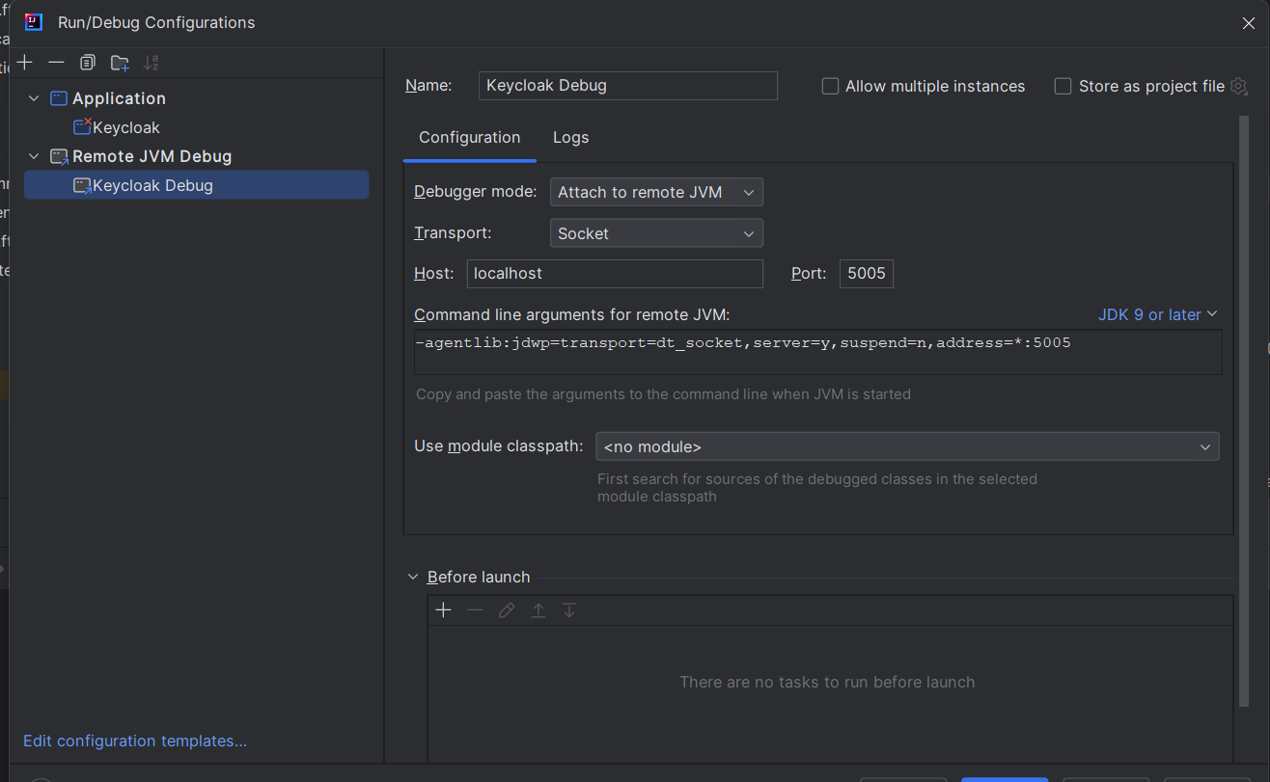

Stop Keycloak:
To stop Keycloak, press Ctrl + C in newly opened terminal.

